Equipment Certification of Decontamination

RMA #

To enable us to comply with the following regulations:

- Health and safety at Work Act 1989
- Control of Substances Hazardous to Health Regulation 1988
- General Applications Regulations 1993
- Chemical Agents Regulations 1994 (Code of Practice S.I.445)

Please complete this form PRIOR to the equipment leaving your laboratory, or where applicable,
PRIOR to any work being carried out on the customer site.

SECTION 1: Description of items (including model and serial numbers, if applicable):
Description of Unit | Specification ID # | Serial Number

SECTION 2: Chemicals or gases (including concentrations) and known by-products, which item may

have contacted in process (note: please do not use acronyms or formulas):
Chemicals & Gases | Concentration | Hazard Class Code (See Next Page)
 |  | Health # | Fire # | Special # | Reactivity #

SECTION 3: Describe the decontamination protocol used on this equipment. Include cleaning and purge procedures, testing protocol, and results of testing.
Decontamination Protocol | Testing Method | Results of Testing

WARNINGS: Identify potential dangers from residual contamination and list precautionary measures including the use of personal protective equipment.
Warnings & Special Handling Instructions

Please refer to the Employee Hazard Communication Card below for the
Hazard Class Codes required in SECTION 2 on the previous page.

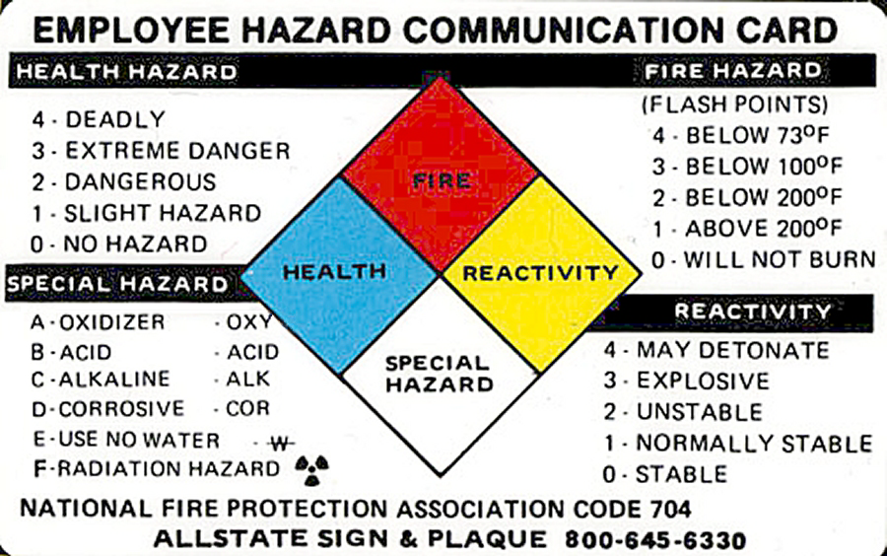

To the best of my knowledge, this document is complete and accurate.
Certification By |  | Telephone
Emergency Contact |  | Telephone
Department & Title |  | Date

Hand Signature Required: ______________________________________ Date:___________________

